LangGraph is an advanced framework within the LangChain ecosystem that is built for ​building stateful, multi-agent applications. ​It is designed to be low-level and flexible, giving you complete control without restrictive abstractions. ​LangGraph is a framework that models agent workflows as graphs where ​Nodes are like individual steps or functions that do the actual computation.
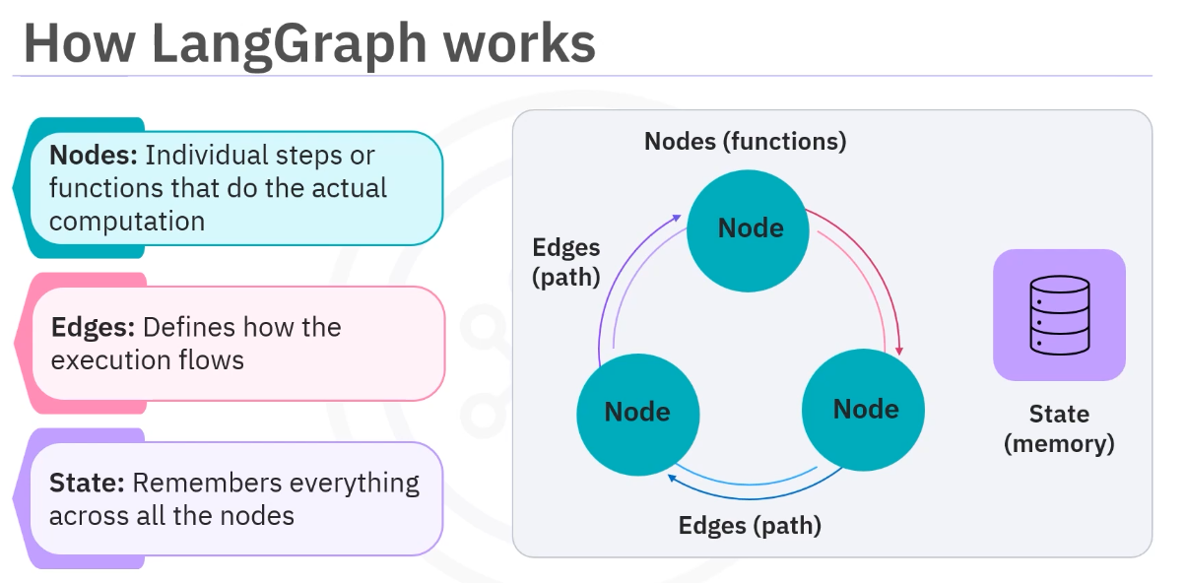
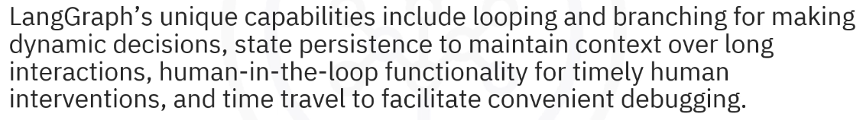
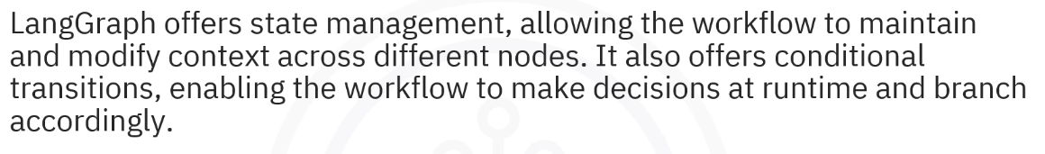
https://chatgpt.com/g/g-p-69e36d1fc94c81918fd97bcb8ea1e70a-agentic-ai-with-langchain-and-langgraph/c/69e616ff-3f74-83e8-8e35-6645e63f46b7

